Complete Login Application using React, Node.js, Express.js and MongoDB
This is a simple, beginner-friendly login application that you can run on your local Windows system. It supports user registration, login, password encryption, dashboard access, and logout.

1. How the application works
React Frontend
Registration, Login and Dashboard
Port 5173
Node.js + Express.js
Handles login, registration and authentication
Port 5000
MongoDB
Stores user name, email and hashed password
Database: loginDB

2. Software required
Install these applications on your computer:
- Node.js (LTS): Download Node.js
- MongoDB Community Server: Download MongoDB
- MongoDB Compass (optional): Download MongoDB Compass
- Visual Studio Code: Download VS Code
Open Command Prompt and check Node.js and npm:
node -v
npm -v
Both commands should display version numbers. Ensure the MongoDB service is running before testing the application.

3. Create the project structure
Open VS Code, open a terminal, and run:
mkdir LoginApp
cd LoginApp

mkdir backend
npm create vite@latest frontend -- --template react
When the frontend setup finishes, your project will contain:
LoginApp/
├── backend/
│ ├── server.js
│ ├── .env
│ └── package.json
└── frontend/
├── src/
│ ├── App.jsx
│ └── App.css
└── .env

4. Develop the backend using Node.js and Express.js
The backend receives requests from React, validates user details, hashes passwords, and checks login credentials.

Step 4.1: Install backend packages
In the VS Code terminal:
cd backend
npm init -y
npm install express mongoose cors dotenv bcryptjs jsonwebtoken

Step 4.2: Create the .env file
Inside the backend folder, create a file named .env.
PORT=5000
MONGODB_URI=mongodb://127.0.0.1:27017/loginDB
JWT_SECRET=replace_this_with_a_long_random_secret
CLIENT_URL=http://localhost:5173
Replace the JWT secret with a long, random secret before using the application. Do not upload .env to GitHub.

Step 4.3: Create server.js
Create backend/server.js and paste the following complete code.
const express = require("express");
const mongoose = require("mongoose");
const cors = require("cors");
const dotenv = require("dotenv");
const bcrypt = require("bcryptjs");
const jwt = require("jsonwebtoken");

dotenv.config();

const app = express();

app.use(cors({ origin: process.env.CLIENT_URL }));
app.use(express.json());

// Connect to MongoDB
mongoose
.connect(process.env.MONGODB_URI)
.then(() => console.log("MongoDB connected successfully"))
.catch((err) => console.error("MongoDB error:", err.message));

// User schema and model
const userSchema = new mongoose.Schema(
{
name: { type: String, required: true, trim: true },
email: {
type: String,
required: true,
unique: true,
lowercase: true,
trim: true,
},
password: { type: String, required: true },
},
{ timestamps: true }
);

const User = mongoose.model("User", userSchema);

// Create a JWT token
function createToken(user) {
return jwt.sign(
{ id: user._id.toString() },
process.env.JWT_SECRET,
{ expiresIn: "1h" }
);
}

// Test API
app.get("/", (req, res) => {
res.send("Login application API is running");
});

// Register API
app.post("/api/auth/register", async (req, res) => {
try {
const { name, email, password } = req.body;

if (
typeof name !== "string" ||
typeof email !== "string" ||
typeof password !== "string" ||
!name.trim() ||
!email.trim() ||
password.length < 8
) {
return res.status(400).json({
message: "Enter your name, a valid email, and a password of at least 8 characters.",
});
}

const normalizedEmail = email.trim().toLowerCase();

const existingUser = await User.findOne({
email: normalizedEmail,
});

if (existingUser) {
return res.status(409).json({
message: "This email is already registered.",
});
}

// Hash the password before storing it
const hashedPassword = await bcrypt.hash(password, 12);

const user = await User.create({
name: name.trim(),
email: normalizedEmail,
password: hashedPassword,
});

res.status(201).json({
message: "Registration successful. Please log in.",
user: { id: user._id, name: user.name, email: user.email },
});
} catch (error) {
if (error.code === 11000) {
return res.status(409).json({
message: "This email is already registered.",
});
}

console.error(error);
res.status(500).json({ message: "Server error during registration." });
}
});

// Login API
app.post("/api/auth/login", async (req, res) => {
try {
const { email, password } = req.body;

if (
typeof email !== "string" ||
typeof password !== "string" ||
!email.trim() ||
!password
) {
return res.status(400).json({
message: "Email and password are required.",
});
}

const user = await User.findOne({
email: email.trim().toLowerCase(),
});

if (!user || !(await bcrypt.compare(password, user.password))) {
return res.status(401).json({
message: "Invalid email or password.",
});
}

const token = createToken(user);

res.json({
message: "Login successful",
token,
user: { id: user._id, name: user.name, email: user.email },
});
} catch (error) {
console.error(error);
res.status(500).json({ message: "Server error during login." });
}
});

// Middleware to protect private APIs
function authenticateToken(req, res, next) {
const authHeader = req.headers.authorization;
const token = authHeader?.startsWith("Bearer ")
? authHeader.slice(7)
: null;

if (!token) {
return res.status(401).json({ message: "Please log in first." });
}

try {
const decoded = jwt.verify(token, process.env.JWT_SECRET);
req.userId = decoded.id;
next();
} catch {
return res.status(401).json({
message: "Session expired or token is invalid. Please log in again.",
});
}
}

// Protected profile API
app.get("/api/auth/me", authenticateToken, async (req, res) => {
try {
const user = await User.findById(req.userId).select("-password");

if (!user) {
return res.status(404).json({ message: "User not found." });
}

res.json({
user: { id: user._id, name: user.name, email: user.email },
});
} catch (error) {
console.error(error);
res.status(500).json({ message: "Could not load profile." });
}
});

// Start the server
const PORT = process.env.PORT || 5000;

app.listen(PORT, () => {
console.log(`Backend running at http://localhost:${PORT}`);
});

Step 4.4: Start the backend
Run these commands from the backend directory: node server.js
Expected terminal output:
Backend running at http://localhost:5000
MongoDB connected successfully
Test the API by opening this address in your browser: http://localhost:5000/
You should see: Login application API is running.
Keep this terminal open while testing the application.

5. Develop the React frontend
Open a second terminal in VS Code.

Step 5.1: Install frontend dependencies
cd LoginApp/frontend
npm install
Create frontend/.env: VITE_API_URL=http://localhost:5000

Step 5.2: Create src/App.jsx
Replace the contents of frontend/src/App.jsx with this code.
import { useEffect, useState } from "react";
import "./App.css";
const API = import.meta.env.VITE_API_URL;
export default function App() {
const [mode, setMode] = useState("login");
const [name, setName] = useState("");
const [email, setEmail] = useState("");
const [password, setPassword] = useState("");
const [user, setUser] = useState(null);
const [token, setToken] = useState(
() => localStorage.getItem("token") || ""
);
const [message, setMessage] = useState("");
const [loading, setLoading] = useState(false);
// Verify an existing session when the page opens
useEffect(() => {
if (!token) return;
fetch(`${API}/api/auth/me`, {
headers: { Authorization: `Bearer ${token}` },
})
.then(async (response) => {
const data = await response.json();
if (!response.ok) throw new Error(data.message);
setUser(data.user);
})
.catch(() => {
localStorage.removeItem("token");
setToken("");
setUser(null);
});
}, [token]);
async function handleSubmit(event) {
event.preventDefault();
setMessage("");
setLoading(true);
try {
const endpoint =
mode === "register" ? "register" : "login";

const body =
mode === "register"
? { name, email, password }
: { email, password };
const response = await fetch(`${API}/api/auth/${endpoint}`, {
method: "POST",
headers: { "Content-Type": "application/json" },
body: JSON.stringify(body),
});
const data = await response.json();
if (!response.ok) {
throw new Error(data.message || "Request failed");
}
if (mode === "register") {
setMessage("Registration successful. Please log in.");
setMode("login");
setPassword("");
} else {
localStorage.setItem("token", data.token);
setToken(data.token);
setUser(data.user);
setMessage("Login successful!");
}
} catch (error) {
setMessage(error.message || "Unable to connect to the server.");
} finally {
setLoading(false);
}
}
function logout() {
localStorage.removeItem("token");
setToken("");
setUser(null);
setPassword("");
setMessage("You have logged out.");
setMode("login");
}
if (user) {
return (
<main className="page">
<section className="card dashboard">
<div className="success-icon">✓</div>
<h1>Welcome, {user.name}!</h1>
<p>You have successfully logged in.</p>
<div className="profile">
<p><strong>Name:</strong> {user.name}</p>
<p><strong>Email:</strong> {user.email}</p>
</div>
<button onClick={logout}>Logout</button>
</section>
</main>
);
}
return (
<main className="page">
<section className="card">
<div className="logo">LA</div>
<h1>{mode === "login" ? "Welcome Back" : "Create Account"}</h1>
<p className="subtitle">
{mode === "login"
? "Login to your account"
: "Register to get started"}
</p>
<div className="tabs">
<button
type="button"
className={mode === "login" ? "active" : "secondary"}
onClick={() => {
setMode("login");
setMessage("");
}}
>
Login
</button>
<button
type="button"
className={mode === "register" ? "active" : "secondary"}
onClick={() => {
setMode("register");
setMessage("");
}}
>
Register
</button>
</div>
<form onSubmit={handleSubmit}>
{mode === "register" && (
<label>
Full Name
<input
type="text"
placeholder="Enter your name"
value={name}
onChange={(e) => setName(e.target.value)}
required
autoComplete="name"
/>
</label>
)}
<label>
Email Address
<input
type="email"
placeholder="you@example.com"
value={email}
onChange={(e) => setEmail(e.target.value)}
required
autoComplete="email"
/>
</label>
<label>
Password
<input
type="password"
placeholder="At least 8 characters"
value={password}
onChange={(e) => setPassword(e.target.value)}
required
minLength={8}
autoComplete={
mode === "login" ? "current-password" : "new-password"
}
/>
</label>
{message && (
<p className="message" role="status">{message}</p>
)}
<button type="submit" disabled={loading}>
{loading
? "Please wait..."
: mode === "login"
? "Login"
: "Create Account"}
</button>
</form>
<p className="footer">
React · Node.js · Express · MongoDB
</p>
</section>
</main>
);
}

Step 5.3: Create src/App.css
Replace frontend/src/App.css with:
* {
box-sizing: border-box;
}

body {
margin: 0;
font-family: Arial, Helvetica, sans-serif;
color: #172033;
background: #f1f5f9;
}
button,
input {
font: inherit;
}
.page {
min-height: 100vh;
display: flex;
align-items: center;
justify-content: center;
padding: 24px;
}
.card {
width: 100%;
max-width: 410px;
background: white;
padding: 32px;
border-radius: 18px;
box-shadow: 0 12px 35px rgba(15, 23, 42, 0.1);
}
.logo,
.success-icon {
width: 54px;
height: 54px;
margin: 0 auto 16px;
display: grid;
place-items: center;
border-radius: 15px;
background: #2563eb;
color: white;
font-size: 22px;
font-weight: bold;
}
.success-icon {
background: #dcfce7;
color: #15803d;
border-radius: 50%;
}
h1,
.subtitle {
text-align: center;
}
h1 {
margin: 8px 0;
font-size: 27px;
}
.subtitle {
margin-bottom: 24px;
color: #64748b;
}
.tabs {
display: flex;
gap: 8px;
margin-bottom: 22px;
}
button {
border: none;
border-radius: 9px;
padding: 12px;
cursor: pointer;
}
.tabs button {
flex: 1;
}
button.active,
form button {
background: #2563eb;
color: white;
}
button.secondary {
background: #e2e8f0;
color: #334155;
}
form label {
display: block;
margin-bottom: 17px;
font-weight: 600;
font-size: 14px;
}
input {
display: block;
width: 100%;
margin-top: 8px;
padding: 12px;
border: 1px solid #cbd5e1;
border-radius: 9px;
outline: none;
}
input:focus {
border-color: #2563eb;
box-shadow: 0 0 0 3px #dbeafe;
}
form button {
width: 100%;
font-weight: bold;
}
button:disabled {
opacity: 0.65;
cursor: wait;
}
.message {
padding: 10px;
border-radius: 8px;
background: #eff6ff;
color: #1d4ed8;
font-size: 14px;
overflow-wrap: anywhere;
}
.footer {
margin-top: 24px;
text-align: center;
color: #64748b;
font-size: 12px;
}
.profile {
margin: 24px 0;
padding: 12px;
background: #f8fafc;
border-radius: 10px;
overflow-wrap: anywhere;
}
.dashboard > button {
width: 100%;
background: #dc2626;
color: white;
}

6. Run the complete application
Keep the backend terminal running. In the second terminal, run:
cd LoginApp/frontend
npm run dev
Vite displays a local address. Open: http://localhost:5173
You should now see the login and registration page.

7. Test the application step by step
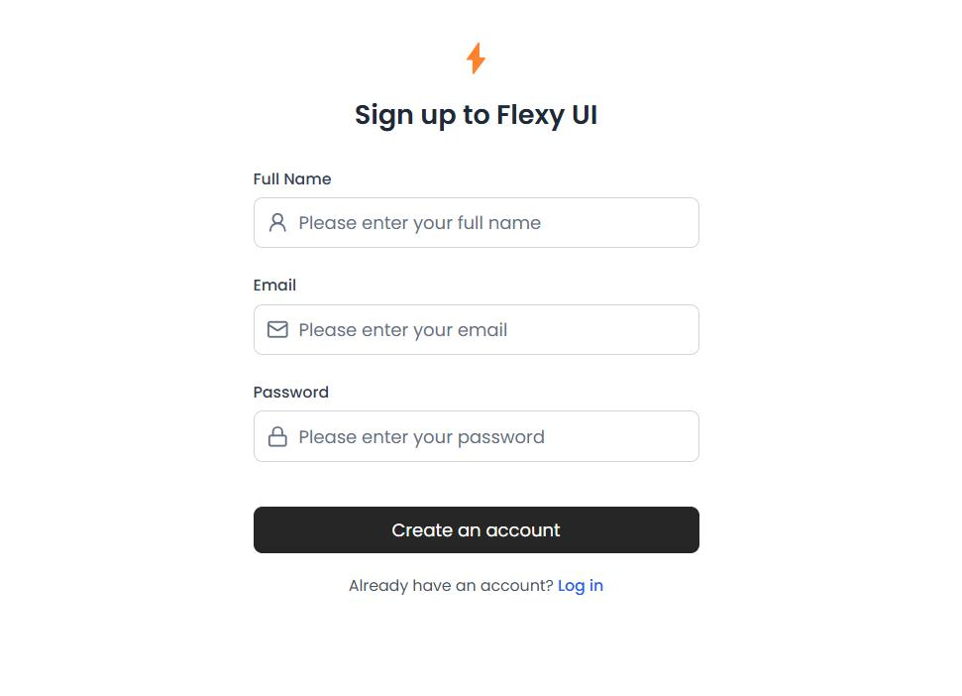
Step 1: Register a new user
Click Register, enter your name, email and password of at least 8 characters, then click Create Account.
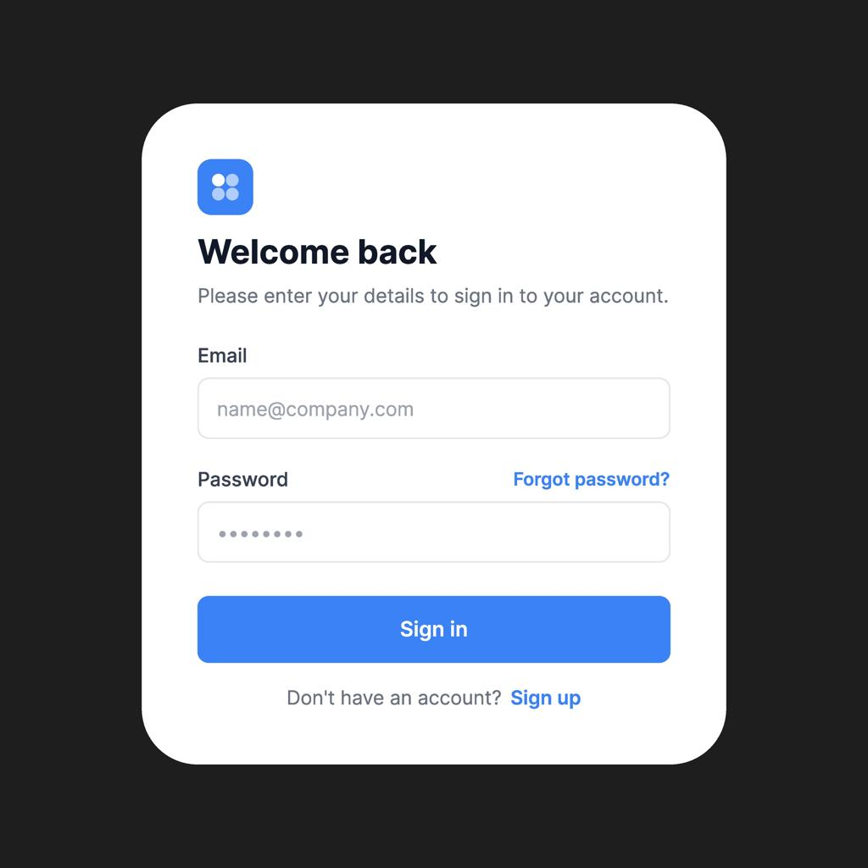
Step 2: Login
Enter the same email and password. Click Login. Correct credentials should open the dashboard.
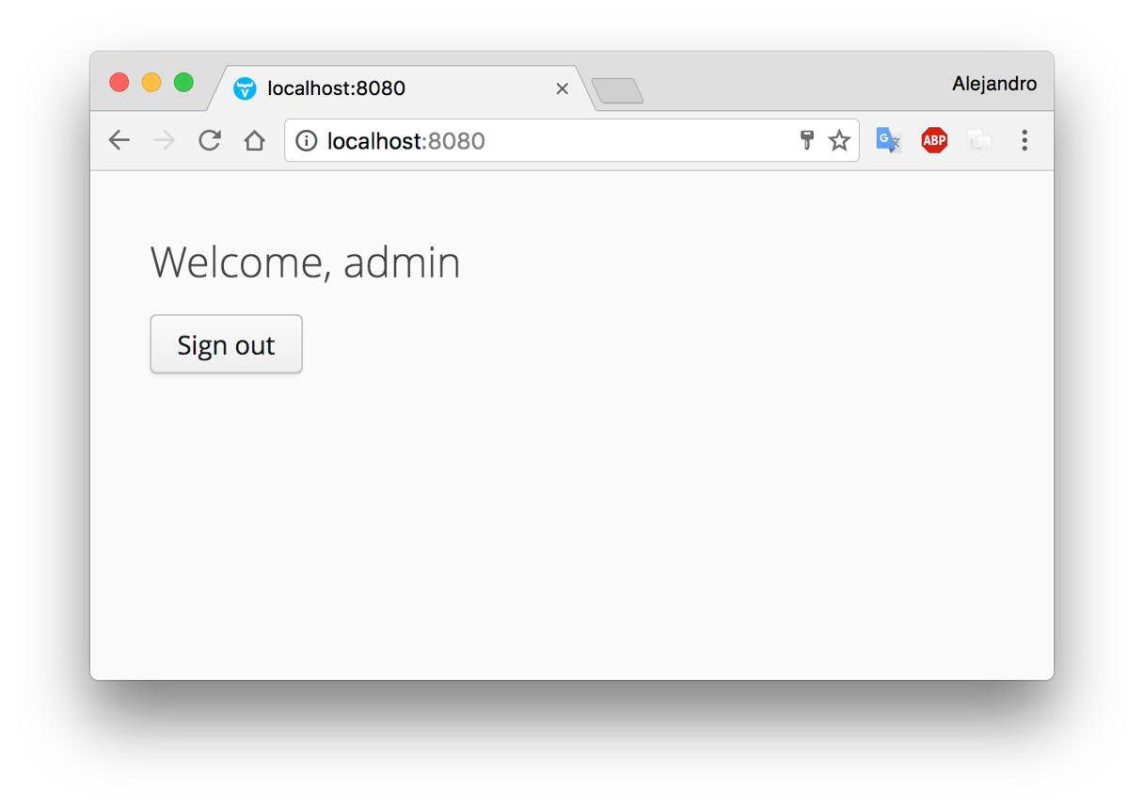
Step 3: Check the dashboard
Confirm that your name and email are displayed. Refresh the page to test session restoration.
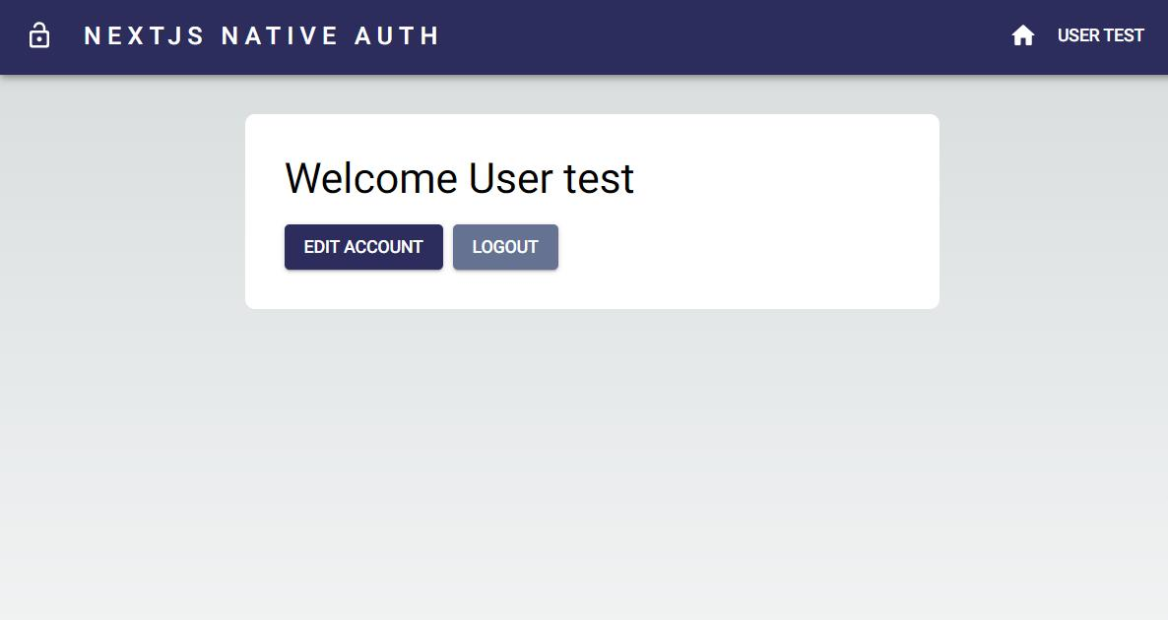
Step 4: Logout
Click Logout. The dashboard should disappear, and the login form should return.

8. Verify registered users in MongoDB
Open MongoDB Compass and connect to: mongodb://127.0.0.1:27017
Then open:
loginDB
└── users
├── name
├── email
├── password
└── timestamps
The password should appear as a bcrypt hash, not as the original password.

9. Common errors and solutions
Error | Solution
MongoDB connection error | Start the MongoDB service and check the connection string in .env.
Failed to fetch | Ensure the backend is running on port 5000 and the frontend API URL is correct.
CORS error | Set CLIENT_URL=http://localhost:5173 in backend .env, then restart the backend.
EADDRINUSE | Port 5000 or 5173 is already in use; stop the other process or choose another port.
Login fails | Register first, then use the same email and password.
Environment variable is undefined | Check the .env file location and restart the appropriate development server.

10. Important security points
This is a learning project. Before deploying it for real users:
- Use HTTPS.
- Use a strong, private JWT secret.
- Add rate limiting to login and registration endpoints.
- Validate and sanitize user inputs on the server.
- Consider secure, HTTP-only cookies instead of storing JWTs in localStorage, which is accessible to JavaScript.
- Add password reset, email verification and account recovery if needed.
Final result: You have a working full-stack login application with React, Node.js, Express.js and MongoDB.

